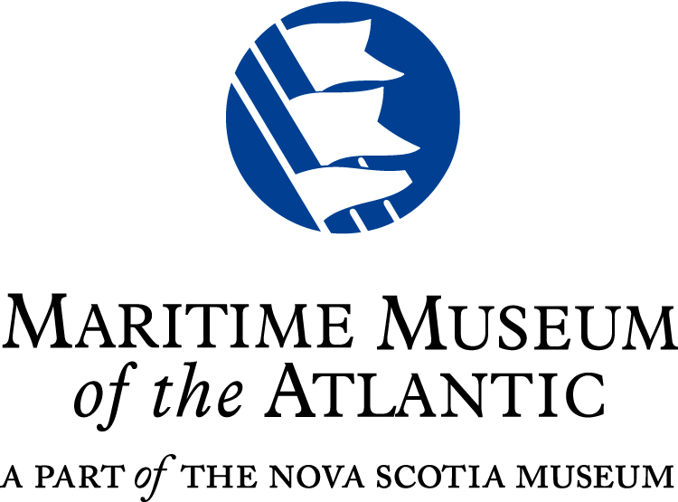

**Incoming Loan Agreement** for ***LEGO: City by the Sea Display***

Duration of DISPLAY: Dec. 17, 2016 through Feb. 24, 2017. Loan Period ­­­­­______________2016 to Feb. 26, 2017

The Maritime Museum of the Atlantic wishes to borrow the following LEGO boat(s): # __________



Owners name (print): _________________________________________________Age: __________________________

Parent or guardians name (if applicable) (print): __________________________________________________________

Address: __________________________________________________________________________________________

Phone: ____________________________________________ E-mail: _________________________________________

|  |  |  |  |
| --- | --- | --- | --- |
| **Boat No.** | **Description (include approx. length)**  **MAX. Dimensions = ~46 cm (~18") long X 18 cm (~7") wide X 30 cm (12") high** | **Condition (if applicable)** | **~ Value (given by owner)** |
|  |  |  |  |
|  |  |  |  |

The Maritime Museum of the Atlantic does not insure the owners boat(s) during transport, storage, or display. Reasonable care will be given to the boat(s) while in the museums custody. The sole responsibility of the Maritime Museum of the Atlantic is that of being voluntary exhibitor of the described boat(s). The Maritime Museum of the Atlantic undertakes to safeguard the described boat(s) to the same and no greater extent as its own collection and is liable to the owner only to the extent that the Maritime Museum is culpably negligent in the receiving, storage, exhibit, and repacking (if any) of the described boat(s). The Maritime Museum of the Atlantic will not clean, alter, or try to repair the boat(s).

It is recommended by the Maritime Museum of the Atlantic - if the Owner requires any form of insurance coverage that the owner make specific arrangements for same at his/her cost.

It is agreed that photographs may be taken by the Maritime Museum for catalogue, education, program, or publicity purposes.

**Lenders signature:** _______________________________________ **Date:** ________________________________

**Guardians signature** (if applicable)**:** ______________________________________________________________

**Museum representative:** _________________________________________________________________________

**At the conclusion of the loan period**, the boat(s) must be picked up by the owner. The copy of your **Incoming Loan Agreement** is required as proof of ownership.

My boat(s) was/were returned is good condition:

**Lenders signature:** _______________________________________ **Date:** ________________________________

**Guardians signature** (if applicable)**:** _______________________________________________________________

**Museum representative:** _________________________________________________________________________

**DON’T FORGET!**

**Your boat(s) should be picked up on Saturday and Sunday, Feb. 25 & 27, 2017** or by no later than 8 pm, Feb. 28, 2017 during regular museum hours.

**NOTE**: Museum closed Mon., Feb. 27, 2017.

***Please present your copy of this form at that time.***

**Unclaimed boats:**

After 30 days, the Museum may dispose of the boat(s).



**Tell us your story about your LEGO model?**

Were you inspired by the sea, something in our museum or had a dream about the ocean?

If you would like to share your story, we would like to share it with our viewers and may post it on the museum’s website, Facebook or Twitter accounts.

Thank you!

Name of Model:_____________________________

The story of your model:

Your First Name: ___________________________